Compare the BRT task in Mirror Steroscope versus Red-Blue Tinted Glasses

1. Task uses the red-blue tinted glasses
2. Another uses the mirror stereoscope with eyetracking.
3. Participants are randomized to do one first or the other.

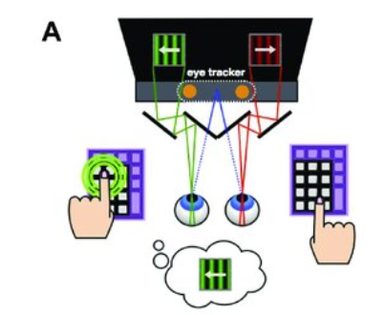

Compare split half reliability. Of mean score, and bias / discrimination ability (full psychometric curve)

Compare correlation to VVIQ.

--

Contact - **Mana Fujiwara**  
<https://www.linkedin.com/in/mana-fujiwara-3a03a14a/?originalSubdomain=jp>  
  
  
is there any other tasks that’s better than the BRT, or that might have convergent validity with the VVIQ? -

is that the best we have because if it is, then we should get that measure completely right, and comparing a good version of the task vs a bad version might make a very good pape

--

Amano Neurofeedback paper.   
Can I drive up the imagery of that red/blue stimulus, and it affects the dominance

Check that it actually activates the regions coding for blue red color in the brain.

Discriminability of the fMRI.

That really really drives home the point.

And it can test for conscious versus unconscious mental imagery.

(remember to find that paper from Sussex, about involuntary mental imagery).

Could do the (Bergmann et al. 2016) setup where it is also orientation.

(then it becomes like Shibata NFB.)

Bergmann, Johanna, Erhan Genç, Axel Kohler, Wolf Singer, and Joel Pearson. 2016. “Smaller Primary Visual Cortex Is Associated with Stronger, but Less Precise Mental Imagery.” *Cerebral Cortex*  26 (9): 3838–50.